Phạm Quang Đức – 22211TT0650

## Question 1

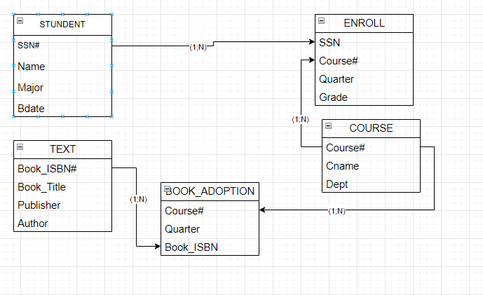

## Question 2

1. Normalize that table structure to the first, second and third normalization forms

* the first normalization forms

|  |  |  |  |  |  |  |
| --- | --- | --- | --- | --- | --- | --- |
| **Invoice#** | **Cust#** | **Name** | **Addr** | **Part** | **Quantity** | **Amount** |
| 1001 | 43 | Jones | 121 1st | Screw | 200 | 2 |
| 1001 | 43 | Jones | 121 1st | Nut | 300 | 2.25 |
| 1001 | 43 | Jones | 121 1st | Washr | 100 | 0.75 |
| 1002 | 55 | Smith | 222 2nd | Motor | 1 | 52 |
| 1002 | 55 | Smith | 222 2nd | Brace | 5 | 44.44 |
| 1003 | 43 | Jones | 121 1st | Saw | 10 | 121 |
|  |  |  |  |  |  |  |
|  |  |  |  |  |  |  |

* the second normalization forms

Bảng Invoice (Invoice# là PK)

|  |  |
| --- | --- |
| **Invoice#** | **Cust#** |
| 1001 | 43 |
| 1002 | 55 |
| 1003 | 43 |

### **Bảng Customer (Cust# là PK)**

|  |  |  |
| --- | --- | --- |
| **Cust#** | **Name** | **Addr** |
| 43 | Jones | 121 1st |
| 55 | Smith | 222 2nd |

Bảng Invoice_Details (Invoice#, Part là PK)

|  |  |  |  |
| --- | --- | --- | --- |
| **Invoice#** | **Part** | **Quantity** | **Amount** |
| 1001 | Screw | 200 | 2 |
| 1001 | Nut | 300 | 2.25 |
| 1001 | Washr | 100 | 0.75 |
| 1002 | Motor | 1 | 52 |
| 1002 | Brace | 5 | 44.44 |
| 1003 | Saw | 10 | 121 |

* the third normalization forms

### **Bảng Product (Part là PK)**

|  |  |
| --- | --- |
| **Part** | **Price** |
| Screw | 2 |
| Nut | 2.25 |
| Washr | 0.75 |
| Motor | 52 |
| Brace | 44.44 |
| Saw | 121 |

1. Draw relational schema diagram for the tables defined in the third normalization form above

